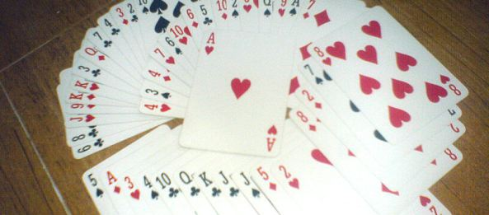

The Game That Is Worth 1,000 Worksheets

Math concepts: greater-than/less-than, addition, subtraction, multiplication, division, fractions, negative numbers, absolute value, and multi-step problem solving.
Have you and your children been struggling to learn the math facts? The game of Math Card War is worth more than a thousand math drill worksheets, letting you build your children’s calculating speed in a no-stress, no-test way.

Set Up
You will need several decks of math cards. Don’t rush to look for these at your school supply store or try to order them through your favorite website. Math cards are normal, poker-style playing cards with the jack, queen, king, and jokers removed. Make one deck of math cards per player. A math deck contains 40 cards, so a single game of Addition War lets a child work 20 problems, and he hears his opponent work 20 more—and if your children are like mine, they will rarely want to stop at just once through the deck.
As my students learn their math facts, they need extra practice on the hard-to-remember ones like 6 × 8. With a normal deck of cards, however, I find they turn up far too many problems like 1 × 9 or 2 × 7. To give a greater challenge to older children, I make each player a double deck of math cards, but I remove the aces, deuces, and tens. This gives each player a 56-card deck full of the toughest problems to calculate.
[This is an old, classic children's game. I've often been amazed how such a simple thing can keep my kids occupied for hours. In our variations, because the math card decks are only 4/5 the size of a regular card deck, we give each player his own pack of cards. We don't shuffle the decks together at the beginning, although I suppose you could—that would be more like the traditional game, which (at least in our house) is usually played with a single deck shuffled and split between the players.]

How to Play
Basic War—Each player turns one card face up. The player with the greatest number wins the skirmish, placing his own and all captured cards into his prisoner pile. Whenever there is a tie for greatest card, all the players battle: each player lays three cards face down, then a new card face up. The greatest of these new cards will capture everything on the table. Because all players join in, someone who had a low card in the initial skirmish may ultimately win the battle. If there is no greatest card this time, repeat the 3-down-1-up battle pattern until someone breaks the tie. The player who wins the battle captures all the cards played in that turn.

Endgame
When the players have fought their way through the entire deck, count the prisoners. Whoever has captured the most cards wins the game. Or shuffle the prisoner piles and play on until someone collects such a huge pile of cards that the others concede.

Variations
For most variations, the basic 3-down-1-up battle pattern becomes 2-down-2-up. For advanced games, however, the battle pattern is different: in case of a tie, the cards are placed in a center pile. The next hand is played normally, with no cards turned down, and the winner of that skirmish takes the center pile as well.
Addition War—Players turn up two cards for each skirmish. The highest sum wins.
Advanced Addition War—Turn up three (or four) cards for each skirmish and add them together.
Subtraction War—Players turn up two cards and subtract the smaller number from the larger. This time, the greatest difference wins the skirmish.
Product War—Turn up two cards and multiply.
Advanced Product War—Turn up three (or four) cards and multiply.
Fraction War—Players turn up two cards and make a fraction, using the smaller card as the numerator. Greatest fraction wins the skirmish.
Improper Fraction War—Turn up two cards and make a fraction, using the larger card as the numerator. Greatest fraction wins.
Integer Addition War—Black cards are positive numbers; red cards are negative. The greatest sum wins. Remember that -2 is greater than -7.
Integer Product War—Black cards are positive numbers; red cards are negative. The greatest product wins. Remember that two negative numbers make a positive product.
Wild War—Players turn up three cards and may do whatever math manipulation they wish with the numbers. The greatest answer wins the skirmish.
Advanced Wild War—Black cards are positive numbers; red cards are negative numbers. Players turn up four cards (or five) and may do whatever math manipulation they wish with the numbers. The greatest answer wins the skirmish.
Reverse Wild War—Players turn up three cards (or four, or five) and may do whatever math manipulation they wish with the numbers. The answer with the lowest absolute value (closest to zero) wins the skirmish.

